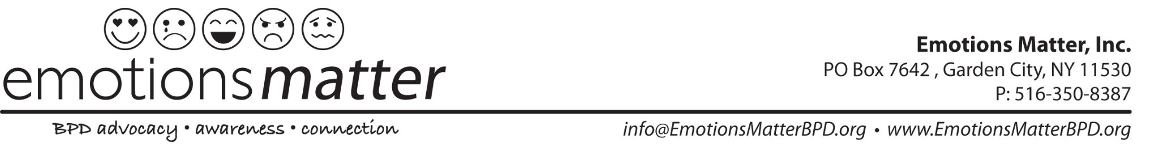

Walk for BPD 2024 - Fundraising Templates (3.22.24)

Here are some resources that you can use when reaching out to your family/friend network to raise money for Emotions Matter’s 2024 Walk for BPD!

EMAIL TEMPLATE:

Dear Friend,

This spring, I will join other walkers for the Walk for Borderline Personality Disorder on June 2, 2024 to benefit Emotions Matter, Inc. This organization and their event are really important to me, and I am working hard to support them.

What is BPD? Up to 1.6% of Americans suffer from borderline personality disorder (BPD), a serious mental illness characterized by emotional dysregulation, impulsivity, depression and suicidality. Thankfully, with proper treatment and community support, individuals with BPD experience meaningful, productive lives.

Why I care: Millions of Americans struggle without access to expensive BPD treatments often not covered by health insurance. BPD continues to be the most stigmatized mental illness, due to lack of public awareness and clinical education. Sadly, up to 10% of those diagnosed with BPD end their lives to suicide.

What the funds are for: I'm participating in this event to try to change that. The Walk for BPD aims to bring public attention to this disorder and to offer the BPD community HOPE. Funds raised from the walk will support Emotions Matter’s innovative peer support group programs, conferences, educational resources and advocacy efforts.

How you can help: When I thought about people who would be willing to help, I thought of you. Would you be willing to donate and help me reach my fundraising goal? If you’d like to help me reach my goal, you can visit my page and make a donation here: (Add Your Fundraising Page Link Here) OR Link to our Walk website: https://givebutter.com/WalkforBPD2024
If you can think of others who might be interested in making a donation, please forward this email to them or share it on social media! Emotions Matter is a great organization and you’d be helping them (and me!) by spreading the word.
Thank you so much for helping me reach my goal, and for supporting Emotions Matter. We couldn’t do it without you!

Sincerely, (YOUR NAME)

WALK FUNDRAISING PAGE STORY TEMPLATE:

Welcome to my Team (Your Team Name)’s fundraising page for the BPD Walk 2024. I am
passionate about the work Emotions Matter does to support people living with BPD.

Every day, people around the United States are diagnosed with borderline personality disorder,
a mental illness that causes behaviors, thoughts and feelings that can be really frightening.
Symptoms of BPD include suicidal thoughts and self-harm behaviors.

People need help to manage their symptoms, but help is often very hard to find. It is hard to
find providers, it is hard to get stigma-free information, it is hard to find support.

Emotions Matter has changed all of that! When people with BPD feel lost or confused, Emotions Matter connects them with a helping hand. They offer free BPD Peer Support Groups,
stigma-free educational resources, programs and events. They provide a supportive community
to support them with positivity and hope on the journey toward recovery.

Will you help support my BPD Walk team so that we can raise critical funds to sustain Emotions
Matter work in 2025?

Any gift, no matter how big or small, will make a difference in the life of someone living with
BPD. https://givebutter.com/WalkforBPD2024

Thank you so much for your support! I appreciate you!

Warm Regards,
(YOUR NAME)

