BPD 2024 Walk Registration Instructions

Note: You must first buy your ticket before you Create a Team or Join a Team

- Visit our walk website: Walk for Borderline Personality Disorder 2024 (givebutter.com)

- Click the “Donate & Tickets” (the purple button)
- Select your ticket type and and select “Continue” (you can add multiple ticket types to one transaction or select multiple of the same ticket type if buying for multiple people).

- Answer all of the questions for your ticket(s).
(Make sure to View our General Consent form before answering YES in the drop down)

- Optional: Make an optional donation in addition to your ticket
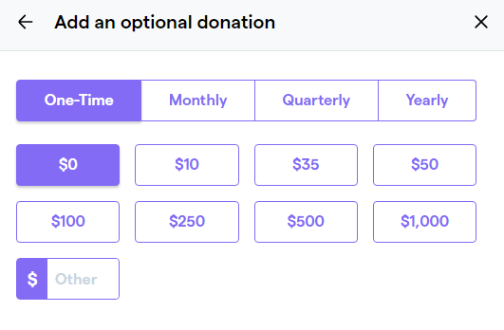
- If you are donating in honor of a Team (or Team Captain), you will be able to “Credit a Team” member at the bottom of the Optional Donation Page. Press “Continue” when done.
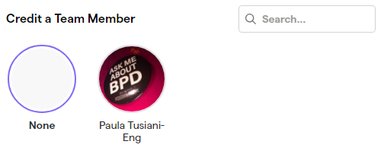
- If you would like to add an inspirational message to our organization or community, you can do so on the “Show your Support” window. Click “Continue”.

- Enter your payment information and click, “Finish”. You will receive your ticket confirmation and email once the payment has been processed.

- Congratulations! You have completed your Ticket Registration - You can now register for/or create a team.

Joining/Creating a Team
Note: Purchase a ticket before you create/join a team
If you have not created a profile for GiveButter (our Walk Website Platform). You will be prompted to create a login when you click “Join a Team”. Create a log in, then follow the steps below.

- Go to our walk homepage: Walk for Borderline Personality Disorder 2024 (givebutter.com)

- Scroll down and click “Join a Team” next to the Team Leaderboard and below our 2022 Walk Video.
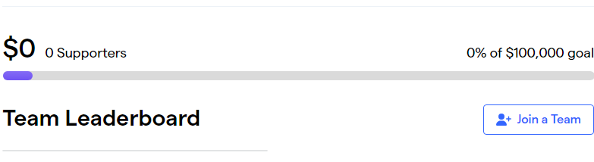

- In the Fundraising PopUp window, click either “Join an Existing Team” OR “Create your own Team”.

If you are Creating your own Team:

- Click “Create your own Team” in the fundraise PopUp
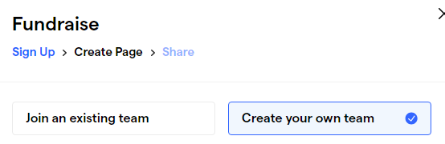
- Fill out the information about your team. Create your team name, upload a team logo (optional). Create your team Fundraising Goal and let us know why you are Walking under your “Story”.

For a Story Template, click here: Fundraising Page Story Template

- Once you fill out your team information, click “Join this Fundraiser”.
- Once you click “Join this Fundraiser” , you will be brought back to the main page, and you will see your group name and story in the Team Leaderboard Section. Everytime you log in, you will be able to see how much your team has raised, and who has joined your team.

After your team has been created, you will be sent an email with your Team Page link that you can share with friends, as well as important information on how to customize your page. If you would like to share this link with your community via email, you can use this template: Email Template

For more information on setting up your page, visit the link: How to manage your team member page | Givebutter Help Center

For an informative video, click the link: How to set up my Team Page

If others want to Join your Team:

- They should purchase their walk ticket first (if they are walking). If they wish to only make a donation, they can select your team in the process.

- Option 1: If you would like people to join your team, they can do so by visiting our Walk Website, scrolling down to the Team Leaderboard window, and selecting “Join a Team”. Once there, they will be able to select your team.

- Option 2: They can click your team name under the Team Leaderboard and be taken to your Team Page. Once there, they can click “Join a Team”.

- Option 3: You can personally email your community with your personal page link that is sent in your confirmation email once you create your team. Once there, they can click “Join a Team” or “Fundraise”. If you would like to share this link with your community via email, you can use this template: Email

Please note: If people joining your team do not have an account, they will be prompted to create one. Once their account is created, their names will show up under your team and any money raised by them will be credited to your team.

If you Joining a Team:
- Click “Join a Team” under our 2022 Walk video, next to Team Leaderboard. If you have not created an account, you will be prompted to do so.

- Once your account is created, you will be able to join the team, create a personal fundraising goal, and donate to the team.

